



..........
.
.
.
.
.
..
.
.
.

Realtime Machine
User’s Manual

RTM-3XX

Revision 1.2 - November 5, 2001

Revision History
.
.
.
.
.
.
..
.
.

Realtime Machine User’s Manual

Description: | Date: | Approved By:
Initial Release | Oct. 10, 2001
Revision 1.0  Changed OS Recovery method | Oct. 16, 2001
Revision 1.1  Updated IP addresses and port numbers  Added numbering and release notes | Oct. 29, 2001
Revision 1.2  Added ActiveSync connection information | Nov. 5, 2001

Table of Contents
.
..
..
.
.

1 Introduction 1
1.1 Realtime Machines 1
1.1.1 Realtime Machine Model Line 2
1.1.2 Development Concepts 3
1.1.3 Packaging List 4
1.2 Host Requirements / Recommendations 5
1.2.1 Host Computer Hardware 5
1.2.2 Host Computer Software 5
1.3 Windows CE 5
1.3.1 Overview 6
1.3.2 Licensing 6
1.3.3 Platform builder and embedded visual tools 6
2 Connecting to the Desktop 8
2.1 ActiveSync Installation 8
2.2 Remote file management and browsing 10
3 Development System Setup 11
3.1 Host Configuration 11
3.1.1 Static IP configuration 11
3.1.2 Embedded tools installation for Ethernet Setup 14
3.1.3 Software Development Kit (SDK) Installation 15
3.2 Connecting to the Target 16
3.2.1 Physically Connecting with Ethernet 16
3.2.2 Testing the Environment 16
4 Application development 22
4.1 Creating a simple VB application 22
4.1.1 Creating a new eMbedded Visual Basic project 23
4.1.2 Building, downloading, and running the application 24
4.1.3 Exiting the application 25
4.1.4 Leaving the application running on the target 25
4.2 Creating a simple eVC++ application 25
4.2.1 Creating a new embedded Visual C++ project 25
4.2.2 Building, downloading, and running the application 27
4.2.3 Viewing build and download results 28
4.2.4 Running the application 28
4.2.5 Observing the debug message 29
4.3 Using the remote tools 29
4.3.1 Remote Process Viewer 29
4.3.2 Remote File Viewer 30
4.4 Application and Link Startup 32
5 Appendices 35
5.1 Installation Troubleshooting 35
5.1.1 Ethernet Communications 35
5.1.2 Tool installation 37
5.2 Target BIOS Settings 37
5.2.1 Standard Settings 37
5.2.2 Integrated Peripherals 37
5.2.3 Features 37
5.3 Target resource map 37
5.3.1 IO Ports 38
5.3.2 Interrupts 38
5.3.3 Memory 38
5.4 ActiveSync Crossover Cable Pinout 38
5.5 Operating System Upgrade and Recovery 38
5.5.1 OS Upgrade 39
5.5.2 OS Recovery 39
5.6 Known Issues - Embedded Tools 41
5.6.1 Windows 98 Slow Debugging 41
5.6.2 New Devices ignored - Slow Debugging 41
5.6.3 Connection problems - CEMGR zombies 41
5.6.4 Multimedia Timers 42
5.6.5 Registry volatility 42
5.6.6 Display driver inefficiency 42
5.6.7 Windows 98 CEMON Debug Error 42
5.6.8 Library missing – wininet.lib 43
5.7 Contacting Realtime Microsystems 43

Realtime Machine RTM-3XX
.
.
.
.
.
.
..
.
.

User’s Manual for the RTM-3XX

- Introduction
This user’s manual is intended to help you set up and use your Realtime Machine. It is organized into five sections:

Section 1 – Introduction
Section 2 – Connecting to the Desktop
Section 3 – Development System Setup
Section 4 – Application Development
Section 5 – Appendices

Realtime Machines
Realtime Machines simplify the development and maintenance of dedicated real-time systems. This is accomplished through seamless integration of low cost readily available PC based hardware, industry standard operating system software and unparalleled software development tools.

The Realtime Machine model line consists of several individual models distinguished by form factor and user interface capability.

As of this date, three form factors are available: Tower, Rack-mount, and PC-104. The availability of several form factors provides the system designer with maximum leverage in finding the right product to fill a particular design need. Each form factor is available in a “headless” version and a “heads-up” version. The heads-up version provides a user interface while the headless version does not. The user interface for the heads-up version includes a graphics display adapter, a keyboard, and a mouse. The heads-up model may be used in headless mode by simply removing the display, mouse, and keyboard.

Although options are available for different form factors and for different user interface capabilities, a tremendous amount of commonality exists between the various models. All models run the most recent version of the Microsoft Windows CE real-time operating system, and are supported by the Microsoft eMbedded Visual tool suite. Therefore development across all platforms is performed in a common consistent manner, using industry standard development tools and a standard Microsoft Windows 32-bit operating system interface.

Realtime Machine Model Line
A brief description of each model in the Realtime Machine model line is given below.

RTM-300 : Headless Tower System
The RTM-300 Realtime Machine is comprised of the following components:

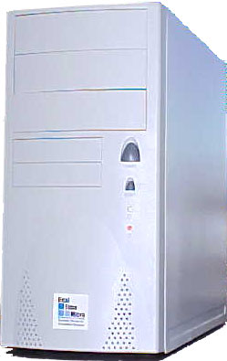 | - Tower case  - Power supply  - Motherboard with CPU, RAM, IO Ports, and expansion slots  - Flash drive card with embedded Microsoft Windows CE  - Ethernet card

RTM-301 : Heads-up Tower System
The RTM-301 Realtime Machine contains all the components as the RTM-300 Realtime Machine with the following additions:
- Mouse  - Video Graphics Adapter  - Keyboard | 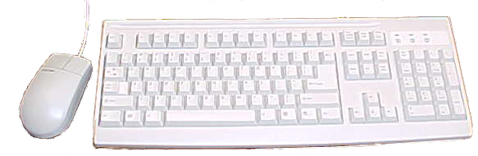

RTM-310 : Headless Rackmount System
The RTM-310 Realtime Machine is comprised of the following components:
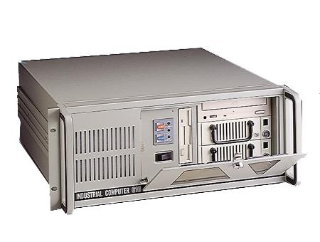 | - 19 inch rack-mountable chassis  - Power supply  - Passive backplane with CPU slot, ISA slots, and PCI slots  - PICMG CPU card with CPU, RAM, and IO Ports  - Flash drive card with embedded Microsoft Windows CE  - Ethernet card

RTM-311 : Heads-up Rackmount System
The RTM-311 Realtime Machine contains all the components as the RTM-310 Realtime Machine with the following additions:
- Mouse
- Video Graphics Adapter
- Keyboard

RTM-320 : Headless PC-104 System
The RTM-320 Realtime Machine is comprised of the following components:

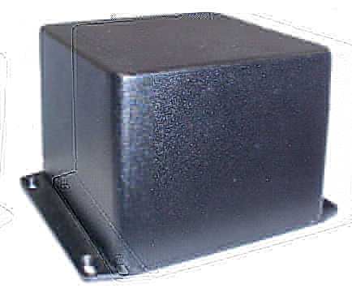 | - PC-104 Enclosure  - PC-104 Power supply  - PC-104 CPU card with CPU, RAM, and IO Ports  - PC-104 Flash drive card with embedded Microsoft Windows CE  - PC-104 Ethernet card
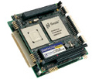

RTM-321 : Heads-up PC-104 System
The RTM-321 Realtime Machine contains all the components as the RTM-320 Realtime Machine with the following additions:
- PC-104 Video Graphics adapter card
- Keyboard
- Mouse

Development Concepts
Some introductory real-time system development information is provided below.

Dedicated Real-time Systems Development
Realtime Machines are designed for use in real-time dedicated systems. Dedicated systems differ from general-purpose systems in that the end use is typically well defined and dedicated to accomplishing a single task. Examples of dedicated systems include robotic systems, web servers, and point of sale systems. After a dedicated system has been fielded, under most situations, only a single application will run on the system, thus competition for system resources is restricted to the design phase.

Real-time systems differ from general-purpose systems in that accomplishing a task on time is equally important to accomplishing the task correctly. In other words, if the task is not accomplished in the time allocated, the results will not be sufficient. Deterministic behavior in such a system is critical. An example of a real-time system is a feedback controller. A feedback controller requires monitoring and adjustment on a periodic basis. If periodic time constraints are not satisfied, the system performance may be unsatisfactorily degraded or even unstable.

Cross Platform Development Overview
Realtime machine software is developed using a cross development process. When a cross development process is used, a host computer develops software for a target machine.

Cross development is different from self-hosted development, where, as the name implies, software development is conducted on the same machine as where developed software is executed. When performing cross development, an extra step is required to download software from the host to target. Quite often, cross development is used when the target does not possess sufficient resources to host a software development system.

When performing cross development, the host machine typically uses a different microprocessor or operating system than the target machine, explaining the term “cross” in cross development.

Packaging List
Each Realtime Machine is shipped with the following items:

Target hardware
Realtime Machine CD
Serial crossover cable
Ethernet crossover cable
Microsoft eMbedded Visual Tools CD’s
Microsoft ActiveSync CD

These items are discussed in more detail below.

Target hardware
The specific items included as target hardware depends on the particular model ordered. Please see the section above titled “Realtime Machine Model Line” for details.

Realtime Machine CD
Realtime Microsystems provides a CD with each Realtime Machine. The RTM-3XX CD contains Realtime Machine Software Development Kits (SDK’s), operating system recovery files, and application development files.

Serial Crossover Cable
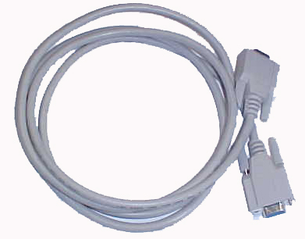 | A Serial Cable is provided to allow direct connection between the host machine and Realtime Machine target. A Serial Cable may be used for a quick plug-and-play Active Sync connection.

Ethernet Crossover cable
The host and Realtime Machine target may communicate through a high speed Ethernet link. An Ethernet crossover cable is provided to allow direct connection between the host machine and Realtime Machine target. | 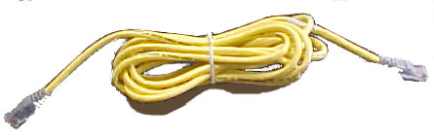

Microsoft eMmbedded Visual Tools CD
A copy Microsoft eMbedded Visual Tools 3.0 CD is included for customer convenience. Microsoft provides the eMbedded Visual tools CD at not cost. | 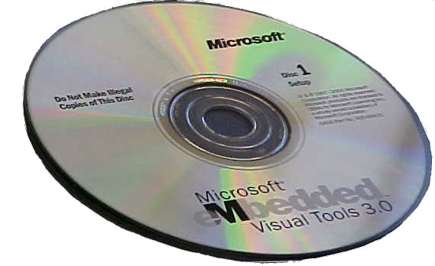

Microsoft ActiveSync CD
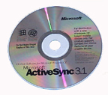 | A copy Microsoft ActiveSync CD is included for customer convenience. Microsoft provides the ActiveSync CD at not cost.

Host Requirements / Recommendations
The following host hardware and software is required or recommended:

Host Computer Hardware
The host computer must be a PC compatible system capable of running a desktop version of Microsoft Windows. It is recommended that the host computer have at least 64 MB of RAM and 100 MB of free hard drive space.

Host Computer Software
A business based version of Microsoft Windows is recommended over a home version. In particular, Microsoft Windows NT Workstation or a derivative is recommended.

Windows CE
Microsoft Windows CE is the operating system used on all Realtime Machines. A brief description of Microsoft Windows CE is provided below.

Overview
Windows CE is Microsoft’s entry into the embedded development space. Windows CE is a modular 32-bit hard real-time operating system that shares many characteristics of Microsoft’s desktop operating systems, yet also differs significantly.

Important commonality with the desktop operating system’s include compatibility with the Win32 API and availability of the Visual tools for software development. Important differences from the desktop operating systems include real-time performance, headless capability, and image size.

Real-time Capability
Windows CE provides hard real-time capability. Desktop versions of Windows provide soft real-time capabilities, at best. Thus if a critical response time is required, a desktop version of Windows will not suffice.

Headless Operation
Desktop versions of Windows will not run without a video display and keyboard. Windows CE can run without a display or keyboard. Thus, dedicated systems that require no user interface are possible when using Windows CE. This is known as headless operation, as described above.

Size
The Windows CE operating system is very compact. On the Realtime Machines, the Windows CE operating system uses as little as 6 MB of disk space. This is compared to 100’s of MB’s typically required by desktop version of Microsoft Windows. A smaller operating system requires less disk space and allows the Realtime Machines to boot far faster than the typical desktop Windows machine. Typical boot time is less than 30 seconds, as compared to minutes with the desktop Windows machines.

Licensing
Unlike desktop versions of the Microsoft Windows operating system, Windows CE is not available in shrink-wrap form. That is, unlike other versions of Microsoft Windows, a consumer may not walk into a department store, purchase Windows CE in a shrink wrapped box, and then subsequently install it on a machine. Windows CE must be purchased with the machine it is to be used on. Operating system upgrades may be purchased from the machine manufacturer, such as Realtime Microsystems, at a later date.

Platform builder and embedded visual tools
A dedicated system developer has two choices when creating a system that runs Windows CE. The developer may purchase a product known as Platform Builder directly from Microsoft and create a custom version of the Windows CE operating system for use with their system. Alternatively, the developer may choose to purchase a platform from a third party vendor with Windows CE already installed, and use the Visual tools to develop application software.

If the developer chooses to purchase Platform Builder, they must spend a fairly significant amount of time developing a custom version of the Windows CE operating system, in addition to the application software. Additionally, they must handle Windows CE licensing issues and pay a hefty license fee for Platform Builder itself.

If the developer decides to purchase a machine that has Windows CE pre-installed, they may immediately focus on application development with the Visual tools. This saves significant engineering effort and reduces time to market.

- Connecting to the Desktop
A key feature of the Realtime Machine is its ability to easily interface with a host desktop machine. This feature is especially important for headless Realtime Machines, where the desktop interface may be the only interface method.

The simplest way a Realtime Machine may be connected to a host desktop machine is using Microsoft ActiveSync software and a serial connection. This method provides an easy, plug-and-play, low cost way to connect. Serial link data transfers at a relatively slow rate of 56 kb/Sec (or .05 Mb/Sec), however this is suitable for remote file management and browsing.

ActiveSync Installation
ActiveSync enables communication between the Host and Target computers. The following paragraphs describe installation of ActiveSync on the host machine, assuming Microsoft Windows NT Workstation is used. Other installations will be similar. If necessary, please consult your Operating System’s User Manual for more information.

To install ActiveSync
- Insert the Microsoft ActiveSync CD into a CD drive on the host. A setup application will launch automatically. (If the ActiveSync CD is unavailable, download the latest version of the software from Microsoft’s website.)
- Connect one side of the crossover serial cable to comm port 1 or 2 on the Host, and connect the other side of the crossover serial cable to comm port 2 on the Target, then select Next.
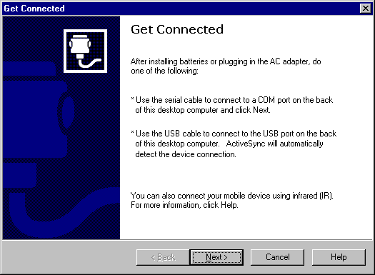

The connection may not be successfully immediately. Several attempts may be necessary to establish the initial connection.

- After an initial connection is detected, select No partnership, then select Next.
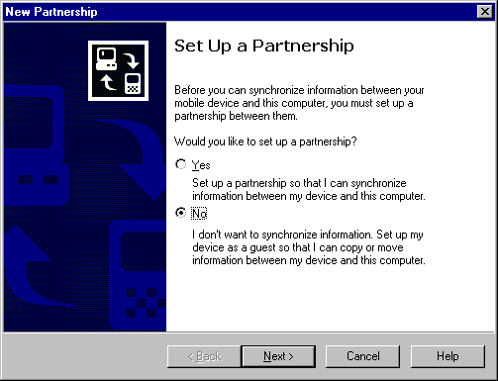

- When ActiveSync connects to the Target, the connection message will appear.
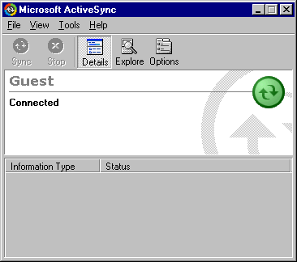

- If a connection is not established, check the serial cable to verify a secure connection exists between the correct comm ports, and try again.

Note: If you would like to use Comm Port 2 on the Target for another application, please refer to section 4.4, Application and Link Startup.

Remote file management and browsing
Once an ActiveSync connection is established, files on the Target can be viewed using ActiveSync or standard Windows desktop tools such as Windows Explorer or My Computer.

To view Target files using ActiveSync
- Click the Explore button on the ActiveSync window.
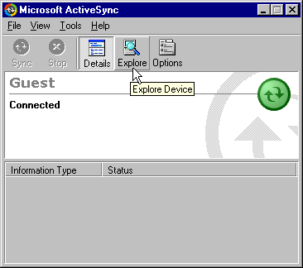

- Double click the My Computer Icon on the Mobile Device window to display folders on the Realtime Machine.
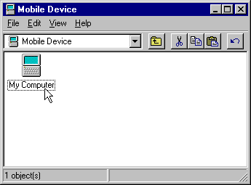 | 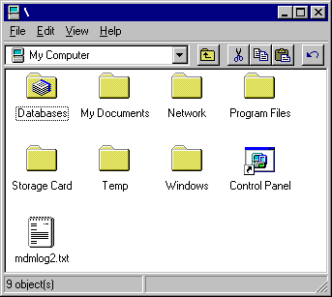

It is important to note that the Realtime Machine folders are stored in RAM and are not intended to store data. When the Realtime Machine is rebooted, any files that have been added to its folders will be lost. The only exception is the Storage Card folder. Data stored in the Storage Card folder will be saved for later use.

- Development System Setup
As described above, software for a Realtime machine is developed using a cross development process. When a cross development process is used, a host computer develops software for a target machine using a remote connection.

There are two options for Realtime Machine software development:
- Serial Link cable with ActiveSync connection
- Ethernet cable with TCP/IP connection

Cross debugging with the serial link connection is extremely slow because of its 0.05 Mb/Sec speed. Cross debugging with the Ethernet link connection is near transparent because of its 10 Mb/Sec speed. Thus the Ethernet cable connection option is strongly recommended for all software development.

Setting up the ethernet development environment is accomplished by configuring the host for TCP I/P, connecting the target to the host with Ethernet cable, and testing the development environment. These steps are described in detail below.

Host Configuration
To develop Realtime Machine target software rapidly, the host computer must be configured to communicate with the Realtime Machine target directly via Ethernet connection. Additionally, software cross-development tools must be installed and configured on the host machine.

The following paragraphs describe host machine setup, assuming Microsoft Windows NT Workstation is used. Other installations will be similar. If necessary, please consult your Operating System’s User Manual for more information.

Static IP configuration
To communicate with the target, a direct TCP/IP connection must be established between the host and target, using static IP addresses. The target’s IP address is factory set to 90.90.90.91. The host must be configured as follows.

The host must have an Ethernet card installed, a TCP/IP stack installed, and the TCP/IP stack must be bound to the specific static IP address of 90.90.90.90.

The IP address can be set when an Ethernet card is installed, or subsequently through the Windows control panel. This document assumes a static IP address is assigned subsequent to installation, however a similar process is followed at installation time.

Note that assigning a static IP address may require rebooting the host computer. Also, before starting static IP assignment, it is recommended that all applications be closed.

To assign a static IP address to the host
- Open the control panel from the Windows Start button.
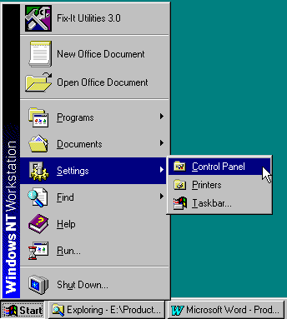

- From the control panel, select Network. A Network dialog box will be displayed as shown below.
- Select the Protocols tab.
- Select the TCP/IP Protocol Network Protocol.
- Push the Properties buttons.
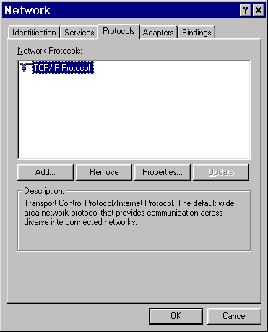

- The following Dialog will be displayed. Verify the proper host network adapter is selected. To set the static IP, choose the Specify an IP address option.
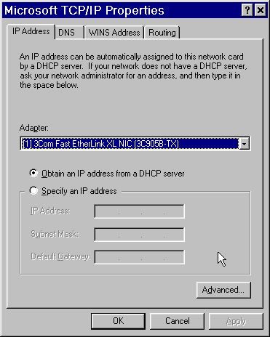

- Set the static IP address as shown below, then select OK.
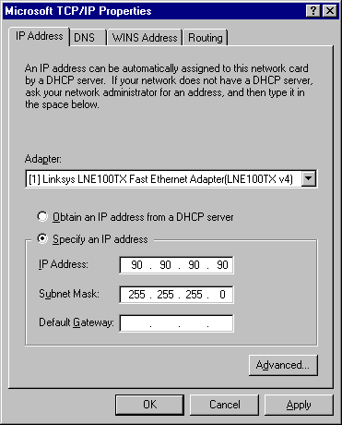

- If requested to reboot, select OK. Otherwise, shutdown and restart the host computer. Upon restart, the host will be assigned the desired static IP address.

Embedded tools installation for Ethernet Setup
Realtime Machine software is developed using the Microsoft eMbedded Visual tool suite. The eMbedded Visual tool suite include eMbedded Visual C++ and eMbedded Visual Basic. This eMbedded Visual tools must be installed on the host before proceeding with software development.

Note: eMbedded Tools 3.0 requires MDAC 2.0 (SP1) or greater. MDAC 2.0 (SP1) is included on the embedded Visual Tools CD to be installed if needed.

To install eMbedded Visual Tools
- Insert the Microsoft eMbedded Visual Tools 3.0 CD #1 into a CD drive on the host. A setup application will launch automatically.

- You will be prompted to select components to install. By default, some Software Development Kits (SDK’s) are selected along with the eMbedded Visual tools. Deselect all the SDK’s, as shown below, then proceed with installation of the eMbedded Visual tools only.
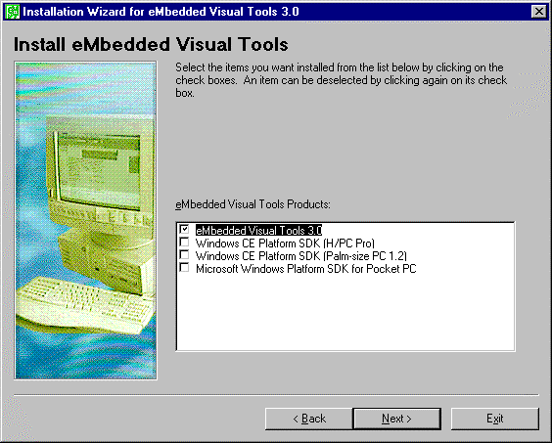

Installation Notes:
eMbedded Visual Tools Disk 2 will not be used for this installation.
Some issues are known to exist with the eMbedded Visual Tools installation process. Please see the eMbedded Visual tools CD for further information.

Software Development Kit (SDK) Installation
The eMbedded Visual tools require a specific SDK be installed to support of a specific platform. All Realtime Machine platforms ship with SDK’s for both embedded Visual C++ and eMbedded Visual Basic. To install the Realtime Machine SDK’s, please proceed as follows.

Installing the eMbedded Visual C++ SDK
To install eMbedded Visual C++ SDK
- Insert the Realtime Machine CD into a CD drive on the host.
- Examine the CD using My Computer or Windows Explorer.
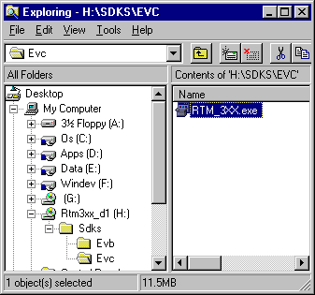

- Go to the Sdks directory, select Evc.
- Execute the RTM_3XX.exe application.
- Follow the instruction displayed on the screen.

Installing the eMbedded Visual Basic SDK
To install eMbedded Visual Basic SDK
- Insert the Realtime Machine CD into a CD drive on the host.
- Examine the CD using My Computer or Windows Explorer.
- Go to the Sdks directory, select Evb.
- Execute the RTM_3XX.exe application.
- Follow the instruction displayed on the screen.
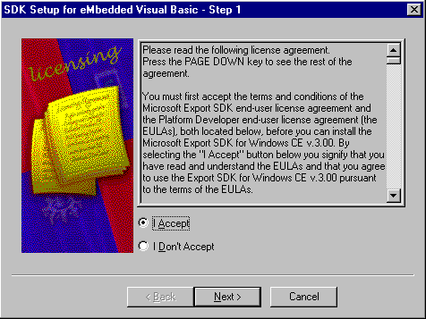

Connecting to the Target

Physically Connecting with Ethernet
To Connect Host and Target with Ethernet Crossover Cable
- Shut down the host computer.
- Remove power from the target, if applied.
- Connect one side of the crossover cable to the Ethernet card on the host, and connect the other side of the crossover cable to the Ethernet card on the target.
- After the computers are connected, restart the host computer, and apply power to the target.

Connection Note:
If the host computer has only one Ethernet card that is normally used for LAN or internet connection, connecting to the target will disconnect the LAN or internet connection.

Testing the Environment
To test the development environment, the eMbedded Visual tools must first be configured to work with the Realtime Machine platform. This is accomplished using the eMbedded tools platform manager.

Configuring eMbedded Visual C++
To configure eMbedded Visual C++
- Start eMbedded Visual C++ from the Windows Start button.
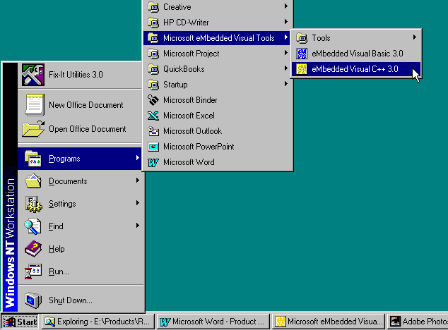

- Once eMbedded Visual C++ is started, select Configure Platform Manager from the Tools menu.
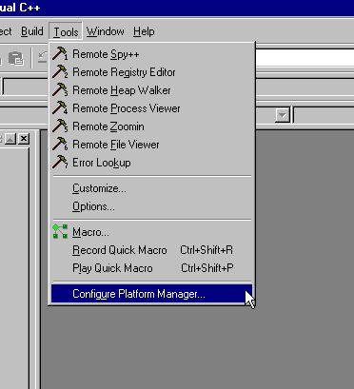

- A Windows CE Platform Manager Configuration dialog box will be displayed.
- Click on the RTM_3XX platform to reveal the RTM_3XX default device.
- Next select the RTM_3XX [Default Device].
- On the Platform Manager dialog box, click on the Properties button.
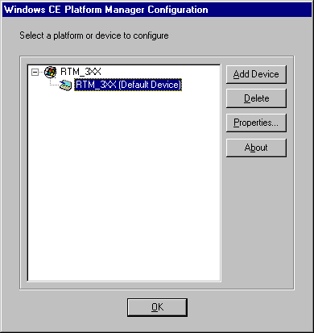

- A Device properties dialog box will be displayed as shown below. Select the TCP/IP Transport for Windows CE and then press the Advanced button.
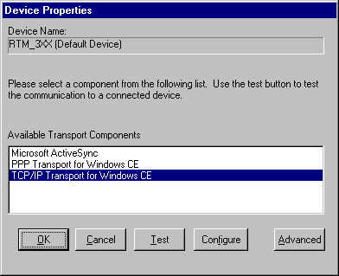

- Select Manual Server from the Available Server Components, and then press OK.
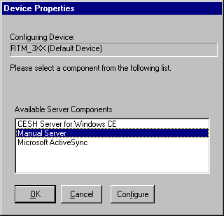

- Next click on the Configure button on the Device properties dialog.
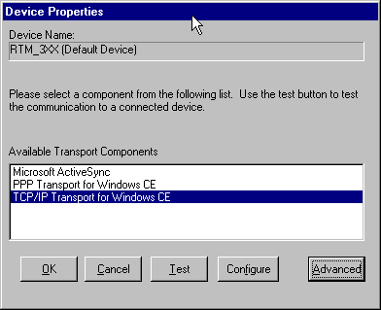

- A TCP/IP transport configuration dialog box will be displayed. Check the Fixed Port option as shown below, using Port Number 2048, and then press OK.
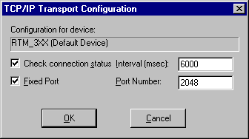

- Next click on the Test button on the Device Properties dialog box. The Manual Server – Action dialog box will be displayed.
- Press OK to begin testing.
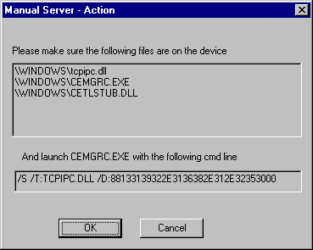

- A Testing Device Connection dialog box will be displayed. The message “Establishing platform manager connection to device” will be displayed as the host tries to connect to the target.
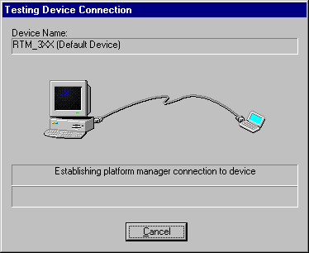

- Upon successful connection, the message “Connection to device established” will be displayed. Select OK to remove the dialog box from the screen.
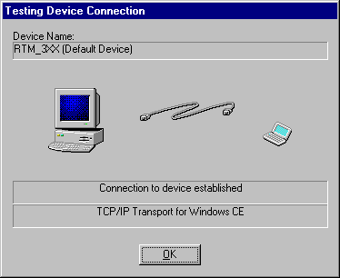

- The connection process is very rapid. If a connection is not established within a few seconds, cancel the Testing Device Connection dialog box, exit eMbedded Visual C++ application, and then restart. Attempt to test the connection again from the Configure Platform Manager - Device Properties dialog box, as described above. If this process fails, please go to the Installation Troubleshooting section in the appendix.

Configuring eMbedded Visual Basic
Configuring eMbedded Visual Basic to work with the Realtime Machine platform is similar to the configuration for Visual C++.
To configure eMbedded Visual Basic
- Start eMbedded Visual Basic from the Windows Start button.
- Select Cancel to remove the New Project dialog box.
- Select Configure Platform Manager from the Tools menu.
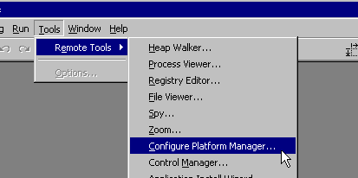

- A Windows CE Platform Manager Configuration dialog box will be displayed.
- Click on the RTM_3XX platform to reveal the RTM_3XX default device.
- Next select the RTM_3XX [Default Device].

- To configure and test the eMbedded Visual Basic environment, follow the instructions outlined above for configuring eMbedded Visual C++.

- Application Development
After the development system has been setup and tested, application development may begin. This section provides examples for creating applications using both eMbedded Visual Basic and eMbedded Visual C++. In addition, an overview of Microsoft embedded remote tools is given, as is a description of how to launch a Windows CE application at startup.

It is worthy to note that the eMbedded Visual tools include a fairly comprehensive help system. Please consult the help system if any additional information is desired.

Creating a simple VB application
For this example, a heads-up Realtime Machine target is used, so the application’s output can be displayed on the target machine’s monitor during runtime.

An application named LinkStartup is running on the target at startup. This application provides the target side with Ethernet communications capability needed for cross development. LinkStartup is closed to reveal the Windows CE desktop. The host-target communication capability will continue even though the LinkStartup application is not visible.
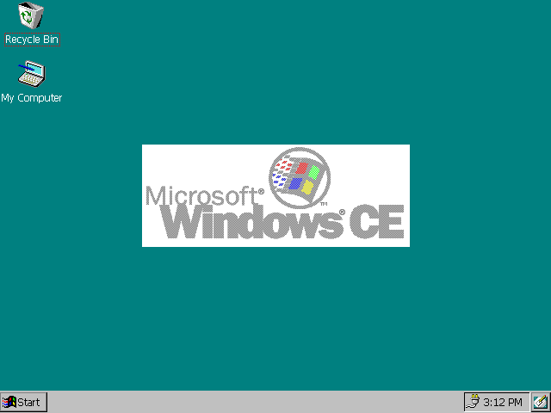
The Windows CE desktop

In the following paragraphs, an ultra simple Visual Basic graphical application will be created, downloaded, and run.

Creating a new eMbedded Visual Basic project
To create an eMbedded Visual Basic Project
- Start eMbedded Visual Basic on the host machine.
- The New Project dialog will be displayed as shown below. If Visual Basic has already been started, Select File, and then New Project from the menu bar to display the New Project dialog.
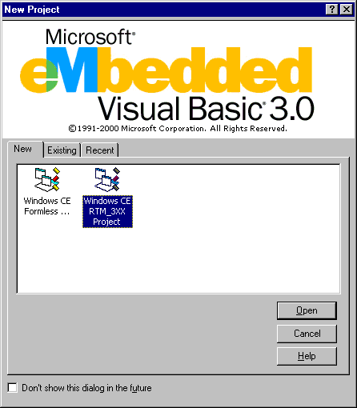
- On the New Project dialog, select the Windows CE RTM_3XX Project and then click on the Open button. A new project will be displayed on the Target machine as shown below.
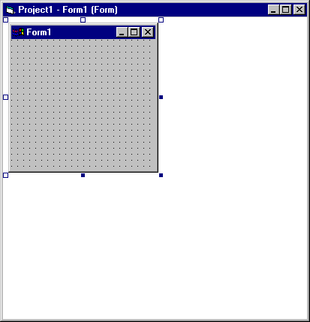

Building, downloading, and running the application
To Run the eMbedded Visual Basic Application
- Click the Run button on the Visual Basic toolbar.
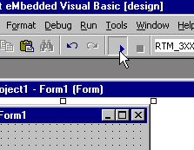

- A manual server – action dialog box will be displayed before the initial download. Press OK to continue

- The application will be downloaded and begin to run on the target. The form will be displayed on the target’s desktop as shown below.

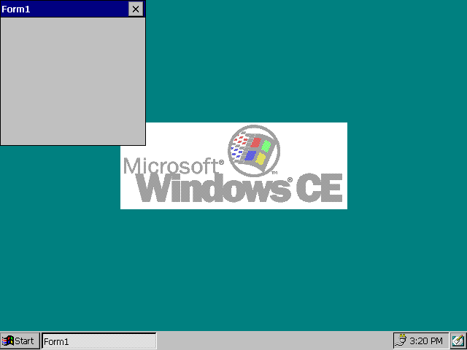
Target Machine’s Desktop

Exiting the application
To exit the Windows CE VB application
- Close it on the target side using the target machines mouse or keyboard.

Leaving the application running on the target
To leave the Windows CE VB application running on the target
- Select the End button on the debug toolbar on the host side. In this case, to continue development, the “pvbload” application will have to be killed using the Remote Process viewer, as described later.
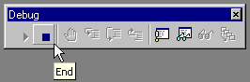

Creating a simple eVC++ application
For this example it is assumed that a headless Realtime Machine is used. Therefore, it assumed that no output is observable on the Target. A simple headless Visual C++ application will be created that echoes a “hello world” debug message for observation on the host.

Creating a new embedded Visual C++ project
To Cretae an embedded Visual C++ Project
- Start embedded Visual C++ on the host machine.
- Select File, and then New from the menu. A dialog will be displayed as shown below.
- Select WCE Application from the Projects tab.
- Verify the CPU selected is Win32 (WCE x86).
- Type in TestApp for the project name.
- Click OK.
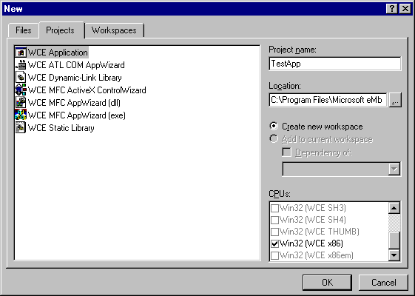

- A New Project Information dialog will be displayed. Click Finish to begin creating the project.
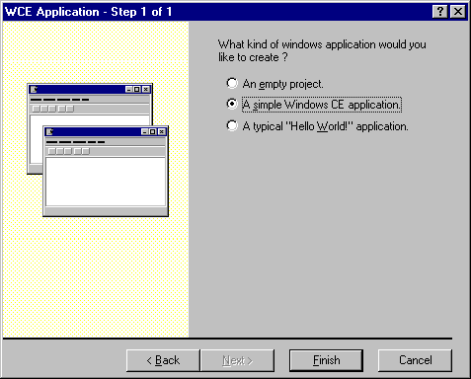

- Press OK to finish creating the project.
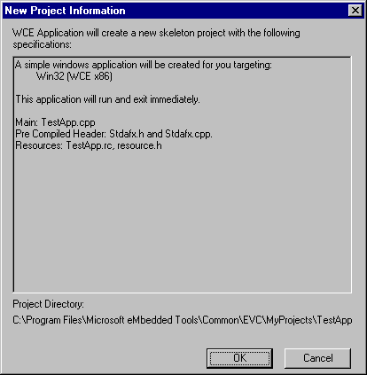

- After the project has been created, open the file TestApp.cpp.
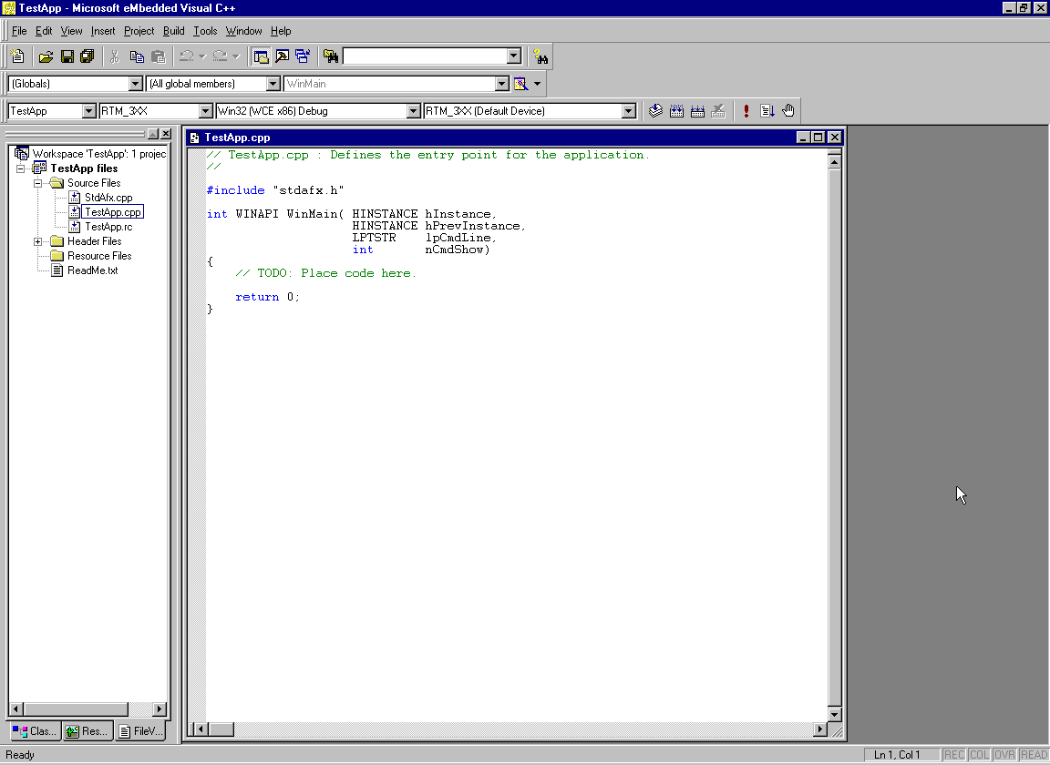

- Add the following debug code to TestApp.cpp after the //TODO comment:

// TODO: Place code here.
DEBUGMSG(1, (TEXT("Hello World\n")));

Note: Please use the eMbedded VC++ help system for additional information regarding DEBUGMSG.

Building, downloading, and running the application
To build, download and run the application
- Click the Build button the Visual C++ toolbar.
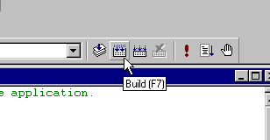
- A manual server – action dialog box will be displayed before the initial download. Press OK to continue

Viewing build and download results
To view results
- Select the Build tab the bottom of the Visual C++ window.
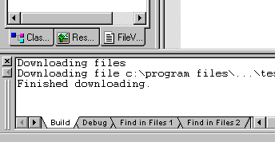

Running the application
To run the application
- Press the Go button on the toolbar.
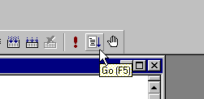

Observing the debug message
To observe the debug message
- Select the Debug tab to examine the contents of the debug window at the bottom of the Visual C++ window. The “Hello World” debug message will be displayed.

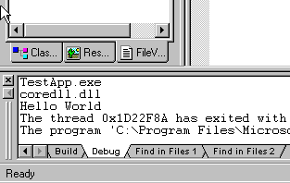

Using the remote tools
The Microsoft eMbedded Visual tool suite provides several remote tools. The remote tools provide the system developer remote access and control of the target system, from the host machine. This is especially valuable when working with a headless system.

The remote tools are accessed from the eMbedded Visual C++ and Visual Basic Tools menu. The eMbedded Visual C++ tools menu is shown below.

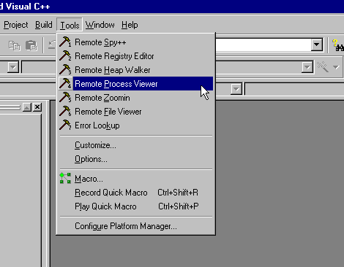
eMbedded Visual C++ Tools Menu

A brief description of a couple key remote tools is given below.

Remote Process Viewer
The Remote Process Viewer tool provides a list of active processes (applications) running on the target machine. When a process is highlighted by double clicking on it with the mouse, a list of associated threads are displayed.
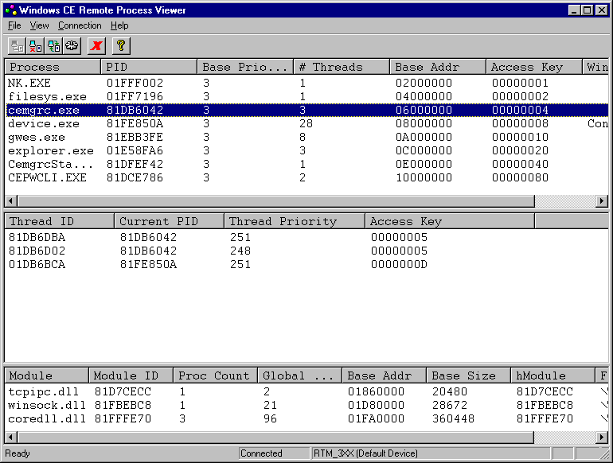
Windows CE Remote Process Viewer

Note: If there are any problems displaying the remote processes, refer to the Known Issues - CEMGR Zombie section of the appendix.

Threads are prioritized in Windows CE, and the highest priority thread that is runable will be active, while lower priority threads are blocked. The highest priority thread is priority 0, and the lowest priority is 255. Windows CE’s preemptive multi-tasking scheduler controls all threads in all processes. To ensure real-time requirements are met, the system designer must be aware of the priority of all threads executing on the target machine.

In addition to threads, the remote process viewer displays a list of dynamic link library modules used by a process.

To terminate a process
- Select the Terminate Process button in the remote process viewer tool.
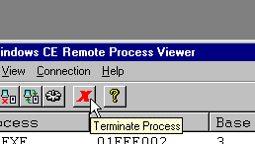

Remote File Viewer
The Remote File Viewer is accessed from the embedded Visual C++ and Visual Basic Tools menu. If the files are not listed, it may be necessary to use the Add Connection button to select the RTM_3xx [Default Device] Windows CE device.
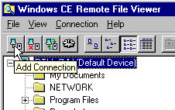

Note that the Connecting to device window may appear, covering the Manual Server – Action window. This is a known issue with this version of Platform Manager.
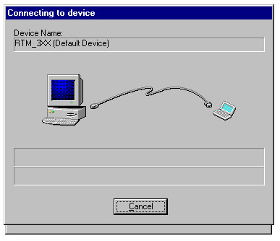
Overlapping Dialog Boxes

It may be necessary to drag the Connecting to device window over far enough to show the Manual Server – Action window. To display data in the remote file viewer, select OK in the Manual Server – Action window.
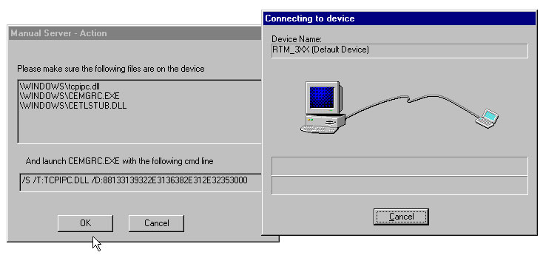
Both Dialog Boxes Visible

The remote file viewer tool provides access to the target file system. Using the remote file viewer, files may be exchanged between the host and target machines, and remote files may be deleted or renamed.

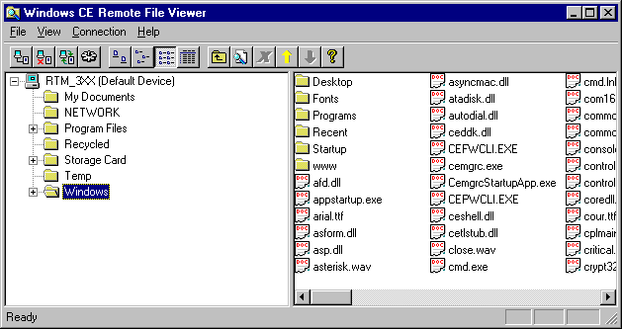

The Windows CE file system is significantly different than the desktop Windows file system. The Windows CE files system is by default volatile. This means that by default, Windows CE loads all files into RAM, and when system power is removed, the files are lost forever.

On Realtime Machines, a storage card and associated Storage Card directory is provided for non-volatile file storage. Thus is it is very important to place all permanent files on the Storage Card in the Storage Card directory.

Application and Link Startup
A Windows CE application may be started using the Windows CE user interface if available, or may be started automatically at startup time. On headless machines, a user interface is unavailable, thus the only option is automatic startup. This section describes the automatic startup process.

When Windows CE boots, it runs applications stored in the Windows/Startup directory.
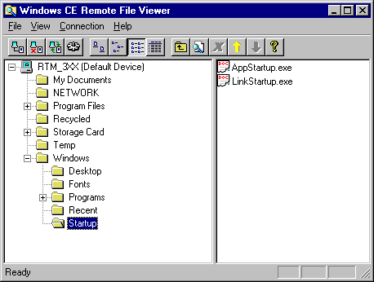
The Windows/Startup Directory

Like all directories except the Storage Card directory, the Windows/Startup directory is non-persistent. This means that files stored to this directory are lost when the system reboots. Thus applications cannot be simply loaded into this directory for automatic startup. Instead an alternative method is available.

On Realtime Machines, two applications are automatically started at boot time: AppStartup.exe and LinkStartup.exe. The AppStartup program looks for a program named App.exe in the Storage Card directory and executes it. The LinkStartup program looks for a program named Link.exe in the Storage Card directory and executes it. The App program is used for automatic application launching. The Link program is used to configure target communications capability.

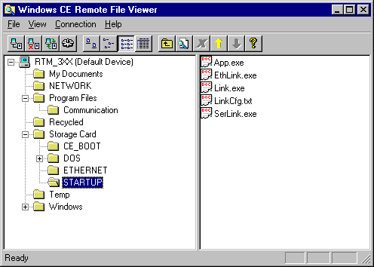
The Storage Card/Startup Directory

If a system developer wishes to start an application automatically, the application must be copied from the host, where it is developed, to the target machines Storage Card directory, and must be named or renamed App.exe. The remote file viewer tool or ActiveSync may be used to accomplish this task.

If the system developer wishes to start more than one application at startup, the developer may create a start application to launch multiple processes using the CreateProcess call from the Win32 API. See the eMbedded Visual C++ help system for additional information on creating processes.

As mentioned earlier, Link.exe is executed at startup to configure target communication capability with the host. The Realtime Machine developer may create their own version of Link.exe, or may use the one provided by Realtime Microsystems. It is assumed here that the Realtime Microsystems version of Link.exe is used.

Link.exe reads a file named LinkCfg.txt file to determine the desired desktop connection(s). LinkCfg.txt contains a decimal value that represents the connection type as described in the table below.

Connection Type | Binary | Decimal
No Link | 00 | 0
Serial Link | 01 | 1
Ethernet | 10 | 2
Both Serial Link & Ethernet | 11 | 3
LinkCfg.txt Values

No link, value 0, is used when the ports on the target machine are required for other purposes. This 0 value tells the Link program to not communicate with desktop at all.

CAUTION: If the Target is headless, do not use value 0 in the LinkCfg.txt file. Once communication is stopped there will be no way to send over the file with a different connection value.

Serial link, value 1, is used for ActiveSync serial connections. Ethernet, value 2, is used for Ethernet TCP/IP connections. Ethernet is recommended for debugging Target software. Both Serial and Ethernet, value 3, is the original value when shipped. If there is no LinkCfg.txt file, or no Link.exe application, the Realtime Machine will assume only a Serial connection is desired.

Appendices
The following appendices are provided:

- Installation Troubleshooting
- Target BIOS Settings
- Target Resource Map
- Operating System Upgrade and Recovery
- Known Issues
- Contacting Realtime Microsystems

Installation Troubleshooting
If a problem occurs during installation please read the appendix section on known issues first, then proceed with the steps outlined below. In the known issues section, pay careful attention to the CEMGR zombie issue, it may likely be the cause of connectivity problems.

Ethernet Communications
Each Realtime Machine and Ethernet crossover cable is tested before shipment. If a communication problem exists, it is likely due to a bad host configuration or poor crossover cable connection.

If communications cannot be established between the host and target, please use the following steps to troubleshoot the problem.

To Troubleshoot Communications
- Verify the crossover cable is securely inserted into the Ethernet adapter cards on both the host and target machines.
- Verify the host has the correct static IP address assigned.
- Ping the target from the host.

If the crossover cable connection is found to be loose, secure the connection and repeat the test described above in the “Testing the Environment” section. If the test still fails, verify the host IP address is correct.
To Verify the host IP address
      - Open a DOS command prompt, and type in the ipconfig command.
      - The host IP address should be set to 90.90.90.90.
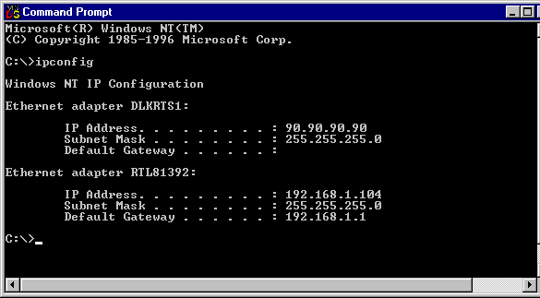

If the host IP address is not set to 90.90.90.90, repeat the steps described above in the Static IP configuration section, and then repeat the test described above in the “Testing the Environment” section. If there are multiple adapters, the first must be set to 90.90.90.90. If the test still fails, try pinging the target machine from the host machine, as described below.

Pinging the target
To Ping the target
- Type in the ping command on the host, specifying the target address. The target IP address is of the Realtime Machine is statically set to 90.90.90.91.
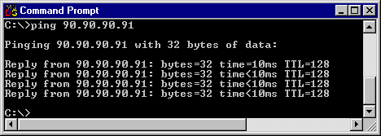

If replies are successfully received from the target, then the communication link is set up correctly. Repeat the test described above in the “Testing the Environment” section. If the test still fails, remove and then reinstall the embedded Visual tools. If the environment test still fails after this, contact Realtime Microsystems for assistance.

If replies are not received from the target, the communications link is still not set up correctly. There may be a problem with the host network adapter. The Realtime Machine target Ethernet adapter card is set to 10 Mbps half duplex. Set the host Ethernet card to use this mode, if possible. As of this writing, some Ethernet cards are known to have problems sensing bit rates and duplex modes.

Repeat the test described above in the “Testing the Environment” section. If the test still fails, try pinging the target with a different host computer. The target is set to 10 Mbps half duplex. If replies are successfully received from the target, then the communication link is set up correctly. Repeat the test described above in the “Testing the Environment” section. If the test still fails, remove and then reinstall the embedded Visual tools. If pinging is still not possible, contact Realtime Microsystems for assistance.

Tool installation
Some issues are known to exist with the eMbedded Visual Tools installation process. Please see the eMbedded Visual tools CD for further information.

Target BIOS Settings
Realtime Machines run on BIOS enabled X86 platforms. In the event of loss or corruption of the preset BIOS configuration, the following configuration is recommended for rapid booting.

Standard Settings
Hard Disks – None
Drive A – None
Drive B – None
Halt On Errors – None (ignore keyboard and graphics for headless systems)
Video – EGA/VGA

Integrated Peripherals
Primary IDE – Disabled
Secondary IDE – Disabled
UART 1 – 3F8 / IRQ4
UART 2 – 2F8 / IRQ3
Parallel Port – Disabled
IRDA Port - Disabled
USB – Disabled
Wake on LAN – Disabled

Features
Quick Power On Self Test – Enabled
Boot Sequence – C Only

Target resource map
Realtime Machines are expandable via the ISA and PCI busses. When expanding Realtime Machines, it is important to understand what hardware resources are dedicated to the Realtime Machine base system.

IO Ports
Hex 2F8 – Serial Port 2
Hex 3F8 – Serial Port 1

Interrupts
IRQ0 – System Timer, used for Windows CE scheduler and Multimedia Timers
IRQ1 – Keyboard
IRQ3 – Serial Port 2
IRQ4 – Serial Port 1
IRQ10 – Ethernet card (may be set otherwise via Plug-N-Play)
IRQ11 – Video Adapter (heads-up systems only)

Memory
Hex D000 – Flash Disk

ActiveSync Crossover Cable Pinout
The crossover serial cable used for ActiveSync is a standard null modem cable. The following table shows the pin settings for a 9-pin null modem. Note: 9 is NC on both ends.
Data Terminal Equipment (DTE) | Data Communications Equipment (DCE) | Label
1, 6 | 4 | CD, DSR - DTR
2 | 3 | RD - TD
3 | 2 | TD - RD
4 | 1, 6 | DTR - CD, DSR
5 | 5 | Gnd - Gnd
7 | 8 | RTS - CTS
8 | 7 | CTS - RTS

The following table shows the pin settings for a 25-pin null modem cable. Note that RTS and CTS are crossed to support hardware flow.
DTE | DCE | Label
2 | 3 | TD - RD
3 | 2 | RD - TD
4 | 5 | RTS - CTS
5 | 4 | CTS - RTS
6, 8 | 20 | DSR, DCD - DTR
7 | 7 | Gnd - Gnd
20 | 6, 8 | DTR - DSR, DCD

Note that some data transfer cables do not connect the DTR signal. These cables will not work with ActiveSync.

Operating System Upgrade and Recovery
The operating system on Realtime Machines may be upgraded when a newer version is available. Additionally, if the Realtime Machine operating system becomes destroyed or corrupted, it may be recovered.

OS Upgrade
Please contact Realtime Microsystems or visit www.RealtimeMicro.com to determine if a newer version of the Windows CE operating system is available. If a newer version is available and an upgrade is desired, please purchase the upgrade from Realtime Microsystems and install it as follows.

The Windows CE OS is encapsulated into a single file named nk.bin. Realtime Machines boot to DOS, then automatically run a program named loadcepc.exe. This program loads the nk.bin file into memory, then launches loadcepc then launches the Windows CE OS. Both nk.bin and loadcepc.exe are located in the Storage Card\CE_BOOT directory on the storage card.

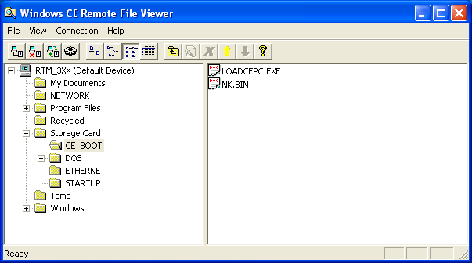

To upgrade the OS, the old version of nk.bin must be deleted, and the new version must be loaded. The simplest way to do this is to use the remote file viewer from one of the embedded Visual tools, or use ActiveSync. If the file is lost or corrupted during the upgrade process, the recovery process outlined below must be followed.

OS Recovery
If the Realtime Machine Windows CE operating system becomes destroyed or corrupted, it may be recovered. To recover the operating system, the flash drive must be formatted as a DOS boot drive, Windows CE must be reinstalled onto the flash disk, and additional initialization files must be copied. Please follow the procedures detailed below to recover the Windows CE operating system.

Create Windows CE Recovery Disks
To recover Windows CE, several files must first be copied from the RTM-3XX CD ROM to floppy disks, then the files must be installed from floppy disk to the Realtime Machine flash drive. To begin this process, please obtain three blank formatted floppy disks, and label them OS 1, OS 2, and OS3 respectively. From the Recovery subdirectory on the RTM-3XX CD, copy the disk subdirectories to the floppy disks. Specifically, copy all files from the disk 1 subdirectory to the OS 1 floppy disk, copy all files from the disk 2 subdirectory to the OS 2 floppy disk, and copy all files from the disk 3 subdirectory to the OS 3 floppy disk. Note that a different computer than the Realtime Machine will be required to access the RTM-3XX CD ROM.

Obtain and Install Flash Card
To allow Windows CE recovery, a DOS bootable flash drive card must be installed in a DOS bootable computer with a 1.44 MB floppy drive, keyboard, and monitor. If possible, it is recommended that the above peripherals be added to the target Realtime Machine. If this is not possible, any standard PC will suffice.

If a standard PC is used, a flash card must be installed. A new flash card may be purchased or the existing Realtime Machine’s flash card may be used. Before installing the flash card, the flash drives base memory address should be set to the value specified in the Target Resource Map section above. Note the flash drive card must host a working DOS flash disk chip.

Boot to DOS from Floppy Drive
Once the flash drive card is installed in the computer, the computer’s BIOS must be set to boot initially from the floppy drive and to disable all hard drives. After the BIOS is set properly, a DOS boot disk should be inserted into the floppy drive, and the computer booted from floppy.

Install DOS on the Flash Drive
Once the computer has booted to DOS from the floppy disk, the flash drive should automatically be recognized as drive C. If the flash drive is not recognized, please contact Realtime Microsystems or the flash drive vendor, M-Systems, Inc., for support.

Next a boot version of DOS must be installed on the flash disk. To install DOS onto the flash drive, please follow the instructions detailed in the DOS documentation. Only a minimal installation of DOS is required. This means only the DOS boot files and himem.sys are necessary to recover and boot Windows CE. It should be noted that the himem.sys file must be installed in the flash drive’s C:\DOS subdirectory.

Reboot to DOS from Flash Drive
After DOS has been installed on the flash drive, the floppy disk should be removed from the floppy drive and the computer rebooted. At this point the computer should successfully boot to DOS from flash.

Install Windows CE Recovery Files onto Flash Drive
To install Windows CE on the flash disk, use the Windows CE recovery disks created above. To start the installation process, insert the first disk into the floppy drive of the computer running DOS with flash card installed. To begin copying files from floppy to flash, execute the ceosbu.exe application located on the OS 1 disk. Then follow the instruction displayed on the monitor, inserting disk 2 and disk 3 when prompted.

When the DOS prompt returns, the OS has been successfully installed. At this point, the OS files are restored.

Replace Flash Card if Necessary
If the flash card is installed in another computer, the card must be placed back into the Realtime Machine. The Realtime Machine should now successfully boot to Windows CE.

Known Issues - Embedded Tools
A description of known issues with the eMbedded tools is provided below.

Windows 98 Slow Debugging
When using the Microsoft Windows 98 operating system on the host computer, the debugger works very slowly. In particular, single stepping through the debugger can be intolerably slow. Thus for any significant development project, it is recommended that a business version of Windows be used.

New Devices ignored - Slow Debugging
When a new device is added in the Windows CE Platform Manager Configuration dialog box it may not actually be used, Platform Manager may still be using the device setup prior to it. To ensure the fast Ethernet connection is being used, unplug the serial cable and inspect the Platform Manager Configuration to ensure it is using TCP/IP Transport for Windows CE. If the host attempts to use the serial ActiveSync connection, the host may need to be rebooted to use Ethernet TCP/IP connection. In the worst case, a complete removal and reinstallation of all SDK’s and embedded tools may be required.

Connection problems - CEMGR zombies
The eMbedded Visual tools rely on a host process named Cemgr.exe to communicate with the target. Often, when communications is inadvertently lost between the host and the target, the Cemgr process is not terminated. This is known as a Zombie process, because it is alive yet no application is using it, thus for all intents and purposes, it is dead.

When an eMbedded Visual tool attempts to reestablish communications with the target, a new instance of Cemgr is launched, however a conflict exists with the old instance of Cemgr, and communications may not be established.

If a communication problem exists between the host and client, it is recommended that the eMbedded Visual tools be exited, and then host active processes be examined. Active processes can be examined using the Windows Task Manager application, or other similar tool. If the Cemgr process is running, kill it, then restart the eMbedded Visual tool.

Multimedia Timers
Realtime Microsystems has built Multimedia Timers into the Realtime Machines. Multimedia Timers provide a stable high resolution timing capability. However some caution must be exercised when using the Multimedia Timers. Multimedia timers should not be created after creating a thread and setting CE thread priority. All multimedia timers must be created before creating sub-threads that call the CESetThreadPriority function.

Registry volatility
On Realtime Machines, the registry is volatile. Thus all persistent application specific configuration data normally stored in the registry should be stored in files in the Storage Card directory.

Display driver inefficiency
It has been observed that video display drivers are highly inefficient, that is considerable processor bandwidth is consumed when performing display operations. It is recommended caution be used when updating the display.

Windows 98 CEMON Debug Error
When you use the eMbedded Visual C++ debugger on a computer that is running Microsoft Windows 98, you may encounter the following error message at the beginning of the debug session: “Error: Platform Manager failed to queue file CEMON.EXE pkg for copying.”. Microsoft has confirmed this to be a bug in the Microsoft products listed at the beginning of this article. This problem has been encountered only on computers that are running Windows 98 Second Edition.

Use one of the following workarounds to enable the Cemon.exe download.
Workaround 1
Reinstall eMbedded Visual Tools Common Components:
- Start the Add/Remove Programs Control Panel application.
- Click Microsoft eMbedded Visual Tools.
- Click Add/Remove.
- Clear the Common Components check box.
- Click OK, click Continue, and then click Yes.
- Click Microsoft eMbedded Visual Tools in the Add/Remove Programs application.
- Click Add/Remove.
- Click to select the Common Components check box.
- Click Continue.
Workaround 2
Install an SDK before installing eMbedded Visual Tools:
- Uninstall eMbedded Visual Tools.
- Install an SDK from eMbedded Visual Tools disk #2.
- Install eMbedded Visual Tools as usual.

Library missing – wininet.lib
When building MFC applications using eMbedded Visual C++, an error is encountered. The error is as follows:

LINK : fatal error LNK1104: cannot open file "wininet.lib"
Error executing link.exe.

The wininet.lib file is not included in the RTM-3XX SDK, however it may be downloaded from the Realtime Microsystems website. Downloading and placing this file in the linkers path will resolve this problem.

Contacting Realtime Microsystems

Office
Realtime Microsystems
5252 Balboa Avenue, Suite 401
San Diego, CA 92117
Voice: (858) 279-RTMS
Fax: (858) 279-7859

World Wide Web
www.realtimemicro.com

E-mail
sales@realtimemicro.com

